CTE PBL Makeover Challenge
When working with Career & Technical Education (CTE) instructors in PBL I often hear the comment, “We already do projects.” This comment is true in that CTE instructors engage their students in authentic projects with students using tools and processes of the trade to produce a product. Students also apply the knowledge and skills they learn through hands-on learning experiences. Yet, these types of learning experiences are not quite PBL experiences because some key elements are absent: challenging problem or question, sustained inquiry, student voice & choice, and public product. So, I challenged CTE instructors to do what they already do but elevate their projects to include Buck Institute for Education’s (BIE) Gold Standard PBL essential project design elements. By doing so, they were able to design an authentic learning experience for their students as they prepare for their chosen career.
Let’s look at how two CTE instructors transformed projects into PBL experiences.
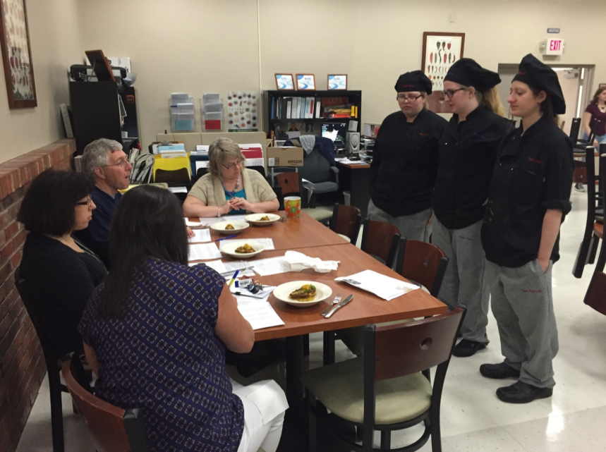
Photo Credit: B. Canorro
In the past, Bob Canorro, Culinary Arts instructor at OCM BOCES, would assign his senior students a country to study from a textbook; create a slide show to present to peers about the herbs, spices, and foods; and design a menu featuring indigenous dishes.

This year, Bob challenged his senior class to propose a menu item for a new restaurant named “Taste of the World”. Students chose a country of interest and researched the same information as in the original project using a variety of resources. Students moved into groups by region-- Central America, Europe, The Mediterranean, The Middle East, Asia, and the United States—where they presented their recipes and collaboratively selected a dish that best represents their region. Student teams had to prepare the selected dish and present the dish to a panel of experts. The experts asked questions about the authenticity of the dish to the region, what cooking method they used to prepare the dish, what might be complimentary side dishes, and the cost of the dish. Bob noted, “I can see this is a better experience for our students because of deeper understanding due to the added dimensions.” Bob was able to transform a typical project into a PBL experience for his students.

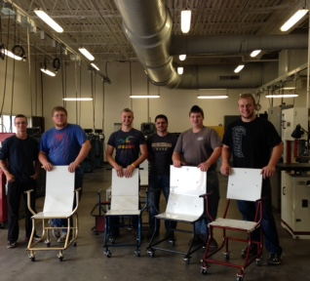
Another transformation occurred in Joe Hawksby’s Advanced Metal Manufacturing class at CiTi BOCES. Usually, Joe would have his students manufacture items using a blueprint, but not this year when he challenged his students to work in teams to design and manufacture a mechanics stool within a given budget. Teams examined a variety of stool designs and melded features they liked into one stool design using AutoCAD. Once the team design was complete, students manufactured five stools. A student involved in this experience said, “I like that we were able to design and create our own stool and draw on each other’s strengths during the manufacturing process.” Joe realized that “when students are required to research and generate their own design, the learning is more meaningful and real.”
Photo Credit: D. Pawlewicz
An additional component to the project was having teams collaboratively write a paper analyzing manufacturing costs compared to stools currently on the market, which led them to answer the driving question: How can we manufacture a competitively priced, quality mechanic’s stool? CiTi students, enrolled in Auto Body Repair and Auto Technology courses, used the finished stools and provided feedback about the quality of design to student teams. In our reflection conversation, Joe thought that next year he will have students ask local mechanics to use the stools for a week and provide feedback about the quality and function of the stool design, adding to the authenticity of the experience. With intentional planning using Gold Standard design elements, Joe was able to deepen his students’ learning in a way that was authentic to the metal manufacturing and fabrication trade.
Are you ready for the CTE PBL makeover challenge? How can you take your hands-on project and use the Gold Standard PBL design elements to transform it to a PBL experience?

