**___________________________________________ Learning Profile**

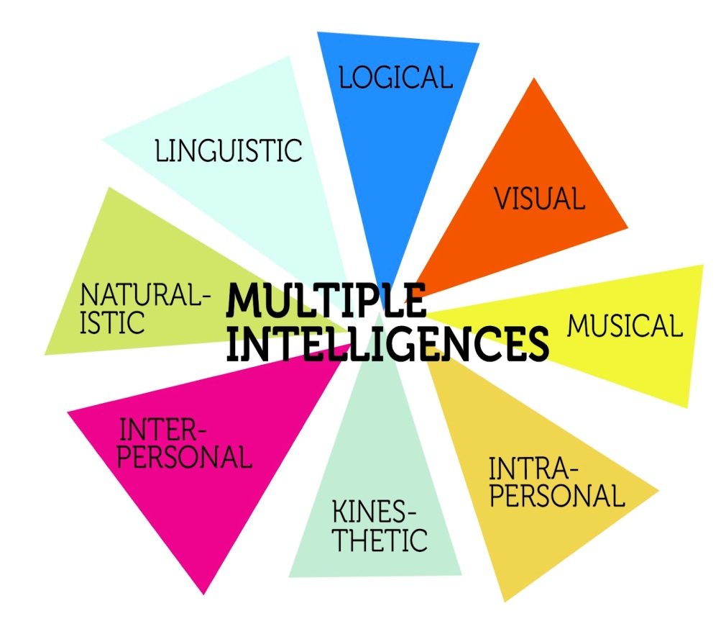

**Areas of Expertise**

