Oswego Health New Vision Students Tackle Issue of Peer Use of Tobacco Products

Written by Steve Yablonski, May 29, 2015

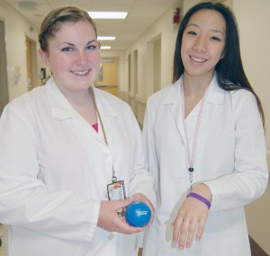
OSWEGO, NY – Oswego Hospital’s New Vision students have spent much of the year studying the tobacco habits of their peers and after collaborating with local agencies have developed strategies that they hope will lead to a lower rate of smoking in Oswego County.

Hannibal New Vision students Rachel Herrmann and Olivia Cacchione show off a stress ball and bracelet that they will hand out to Hannibal students as a way to reduce student smoking.

The students are high school seniors enrolled in the Center for Instruction, Technology and Innovation’s Allied Health New Vision Program.

Throughout the school year they have been taking part in rotations at various Oswego Hospital departments two days a week, which expose them to healthcare careers. Each year the class takes on a major project and this year the students reviewed the Oswego County Community Health Assessment, which includes facts on the health status of residents, including smoking.

According to the document, 32 percent of county residents smoke, compared to 18 percent statewide.

The morning and afternoon New Vision participants worked together to create a ten-question survey that they distributed to students in eight county school districts.

After reviewing the nearly 2,000 completed surveys, the students were surprised to learn that many students begin using tobacco products at age 14.

“I didn’t know that people started smoking at such a young age,” said Karli Bricker, a student from Fulton.

The surveys further indicated that most students started smoking out of curiosity and due to stress.

Using their data, each class divided into groups to develop ideas on how best to reduce the use of tobacco products among their peers.

Those projects were then presented to a project selection panel that included Oswego Health’s Community Education Nurse Susan Callaway, Oswego County’s Director of Public Health Jiancheng Huang and Julie Reid, a registered nurse at Northern Oswego County Health Services Inc.

The panel selected the morning’s class project that will introduce the use of stress relievers in the Hannibal Middle School and High School.

Through a grant from the Rural Health Network of Oswego County, the students were able to purchase stress balls and bracelets that carry the slogan, take down tobacco.

Olivia Cacchione, a Hannibal student has been working with the Hannibal School Principal Stephen Dunn to coordinate a school assembly and distribution of the stress balls and bracelets.

“He has been really helpful throughout the project, as he feels it is very important,” Cacchione said.

Working alongside Cacchione has been Rachel Herrmann, who developed the budget for the project.

Meanwhile, for the afternoon class, the panel chose a project that will offer an afternoon of presentations at the Altmar-Parish-Williamstown Middle School.

As part of the presentations, students will be asked to breathe through straws to simulate a reduced lung capacity as a result of smoking, while a second station will represent the weight and size of an average oxygen tank used by those who have emphysema.

Not only have the students worked with school district officials, they have also shared their projects with members of the Oswego County Legislature’s health committee, who the students said were impressed with their initiatives.

“It was exciting to know that they believed in our projects,” said Nichole Fitzgerald, of Phoenix.

Overseeing the projects has been New Vision Instructor Kim Wright.

“I am so proud of these students,” she said. “They have worked on these projects the entire year and have gone above and beyond. It’s also nice to know that these future healthcare workers are getting involved in an important community issue.”

Members of the public can learn more about the student projects on June 2 and 4 from 9 to 11 a.m. and noon to 2 p.m. both days in three locations: the Oswego Hospital lobby, the south entrance to the Health Service Center and the lobby of the Fulton Medical Center.

Hannibal New Vision students Rachel Herrmann and Olivia Cacchione show off a stress ball and bracelet that they will hand out to Hannibal students as a way to reduce student smoking.

CiTi New Vision Students Implement Projects Aimed At Decreasing Tobacco usage

The Oswego Community Health Assessment completed by the Oswego County Health Department found that nearly 32% of adults across the county smoke, 28% of pregnant women smoke and the cancer mortality rate is the highest in the state.
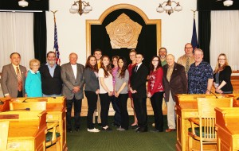

New Vision students from the Center for Instruction, Technology and Innovation stand with their teacher, Kim Wright, their principal, Marla Berlin, and members of the Oswego County Legislature Health Committee.

After reading these shocking statistics, New Vision Allied Health students from the Center for Instruction, Technology and Innovation decided to brainstorm preventative measures and research statistics pertaining to tobacco usage in schools.

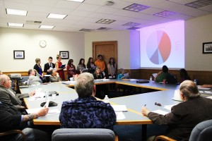
With the collaboration of school administration and staff, the New Vision students were able to implement a survey to grades 9-12 regarding tobacco usage in eight component school districts.

Receiving over two thousand submissions, information was inputted into an excel spreadsheet for analyzing.

CiTi New Vision Allied Health students present their projects that will be implemented in the APW and Hannibal school districts, aimed at preventing youth in Oswego County from choosing to use tobacco products.

The data showed that many students are fairly educated on the negative health effects caused by tobacco products.

While traditional cigarettes were the most commonly used tobacco product, e-cigarettes seem to be an increasingly growing trend.

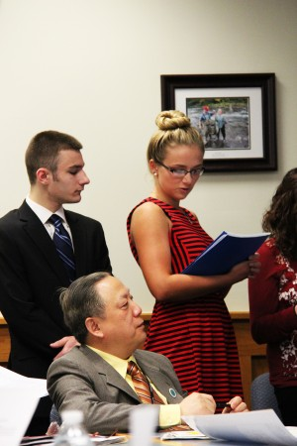
Lastly, the average age that students start using tobacco products is 14.

The New Vision students split up into groups and utilized these discoveries to devise ways to solve the problem.

Ideas were presented to a panel of health experts including Oswego County Public Health Director Jiancheng Huang, Oswego Health RN CDE Susan Callaway and NOCHSI RN Julie Reid.

Using a rubric that addressed criteria such as feasibility, likelihood of success and comprehensive budget, the panelists chose one idea from both of the morning and afternoon classes to move forward with implementation.

One group is in the process of piloting their idea at the Altmar-Parish-Williamstown Central School District.

They plan to inform and educate on the negative effects of peer pressure surrounding tobacco use with a program called “Students Against Smoking.” Their presentation will target seventh and eighth grade emotions and use hands-on activities to show them how tobacco usage affects their lives and loved ones.

Oswego student Kellie Gorman and Mexico student Tom Paronett present their tobacco prevention programs to the Oswego County Legislature Health Committee. Also shown is Oswego County Public Health Director Jiancheng Huang.

Some demonstrations will include performing tasks with a mock oxygen tank and attempting to breathe through a straw after physical activity to demonstrate reduced lung capacity. Collaboration with the APW drama club will produce empowering skits that show students how to turn down tobacco products.

The data collected by the New Vision students indicated stress to be one of the most influential factors of students deciding to use tobacco projects. The second group is currently working with the Hannibal Central School District to implement a stress relief program

Doing significant research on relieving stress, the students found that stress balls, scented hand sanitizer with stress-relieving oils, inspirational bracelets, sugarless gum and dark chocolate are all shown to relieve stress.

The students hope to make these items available in the school nurse’s office. Another part of the project involves a school presentation on how to manage the process of quitting tobacco usage, which can be difficult.

The students that devised both of these ideas were Nicole Fitzgerald (Phoenix), Trevor Allard (Mexico), Kristen D’Angelo (Hannibal), Olivia Cacchione (Hannibal), Kellie Gorman (Oswego), Tom Paronett (Mexico) Kaitlin Ballard (Oswego) and Leah Ruggaber (APW).

Both projects involve a financial cost factor, and each group was asked to create a budget necessary to put their plans into action. Impressed by their work, the Rural Health Network of Oswego County agreed to back their funding to get the programs off the ground.

“The community has been such a great supporter of the students throughout this year,” said New Vision Allied Health instructor Kimberly Wright. “Specifically, I would like to recognize the pivotal role the Oswego County Public Health Director [Jiancheng Huang] has played. He has supported them [the students] every step of the way, provided them with numerous resources and shared with them his expertise in epidemiology.”

Huang arranged for the students to present their projects to the Oswego County Legislature Health Committee where they had the opportunity to see a wing of government in action.

The committee was impressed with their work and offered some encouragement and insight to make the programs even better: social media integration, a greater focus on chewing tobacco and e-cigarettes and a survey follow-up after implementation of the programs. “I want to congratulate these groups,” said Oswego County Legislature Health Committee Chairman Jack Proud. “I want to applaud the statistics and the poise with which they gave their presentations.”

